How to match Bluetooth for computer and printer?
- Firstly please confirm the NAME and PIN of the printer’s Bluetooth via Self Test (When printer is connected power, press 'FEED' button and turn on at the same time, 2 seconds later release 'FEED' button, a completed self test will be printed out to show printer settings. Usually NAME: Printer001, PIN: 0000) . Selftest as the following:
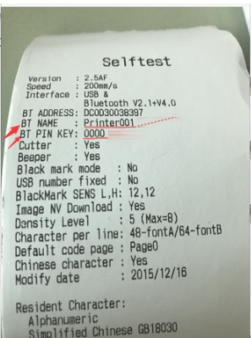

- Open ‘Settings’ - ‘Device’ - ‘Bluetooth’ On - ‘Add a Device’:
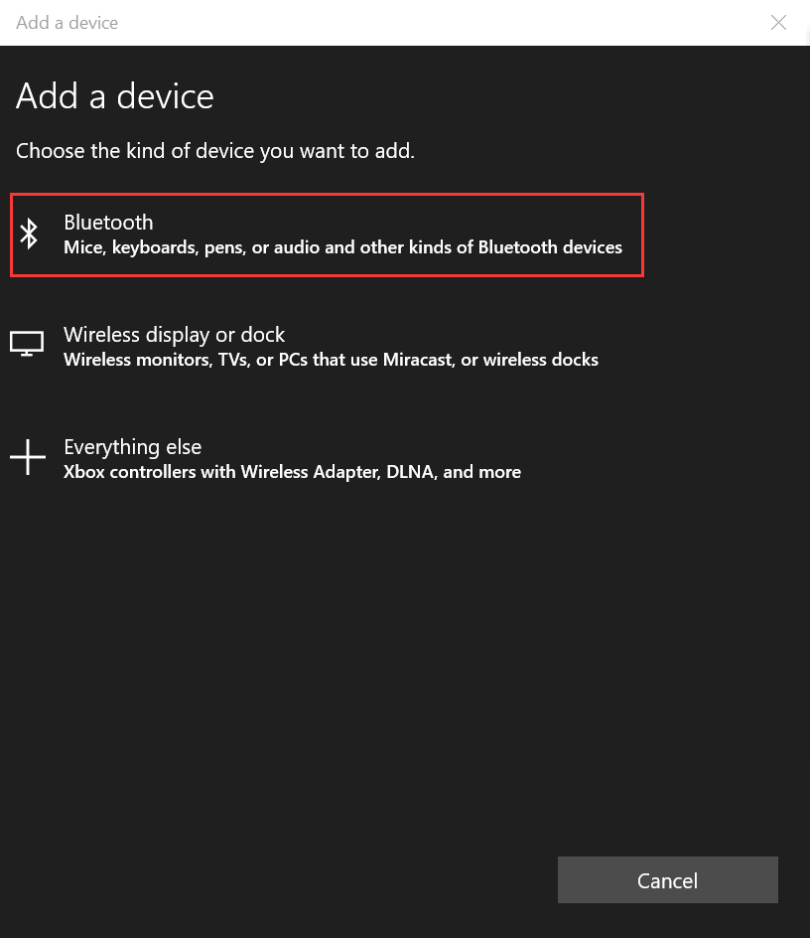

Choose ‘Printer001’:
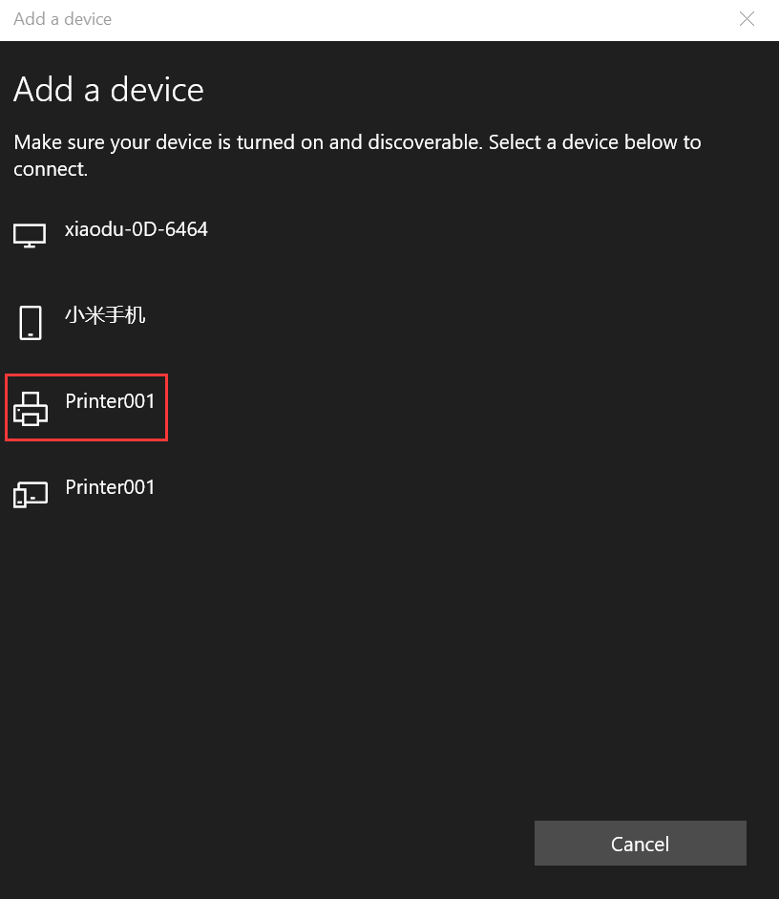

Enter the PIN for Printer001 ‘0000’:
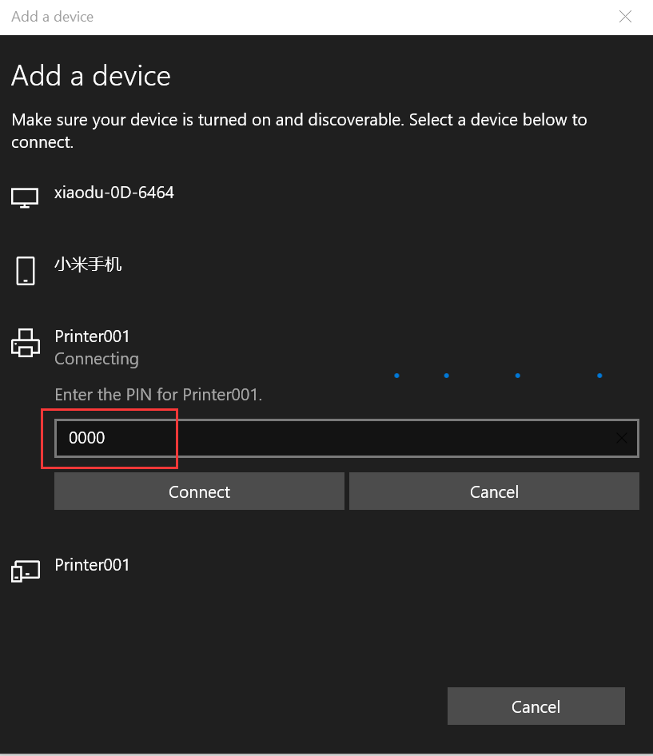
Pared successfully:
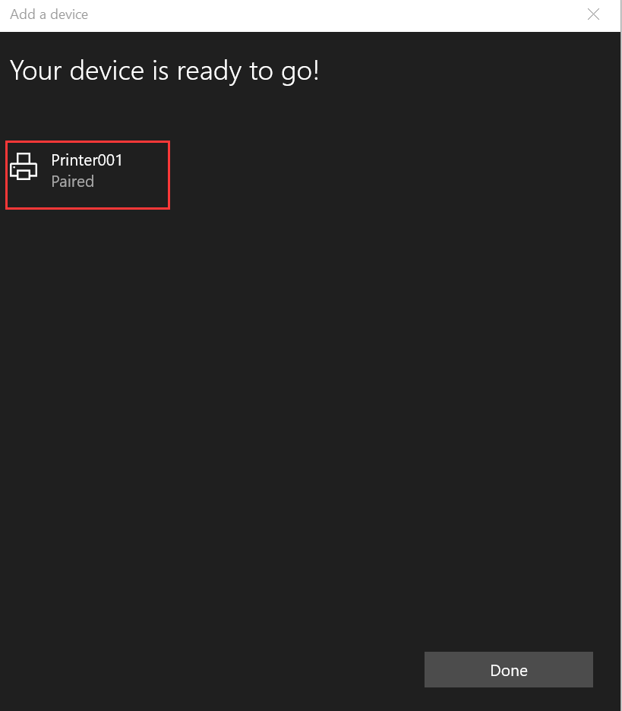

- Go to the ‘Printer and Scanner’ to find ‘XP-80C’, click ‘Manage’:
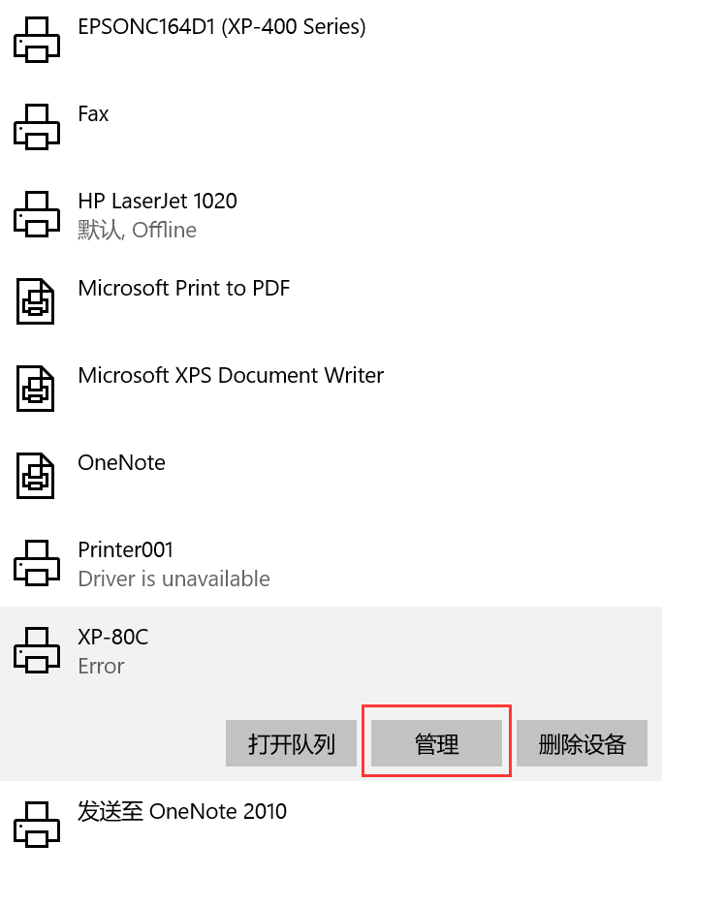
Choose “Ports”-’COM3’ or ‘COM4’-Apply:
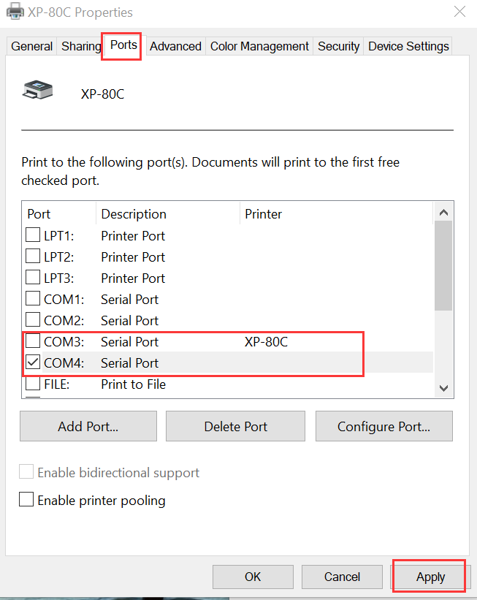

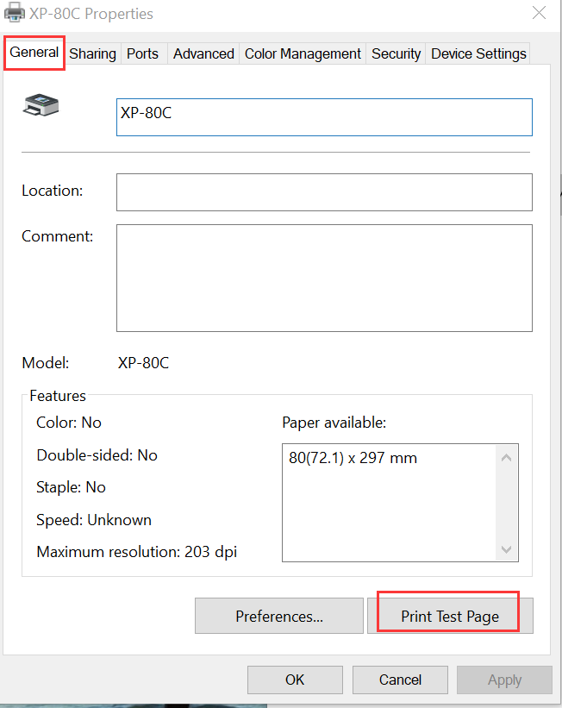

Please email to us if can't connect by Bluetooth.

