How to install Driver in Windows system?

- Open the Driver, click ‘I accept the agreement’, Next:
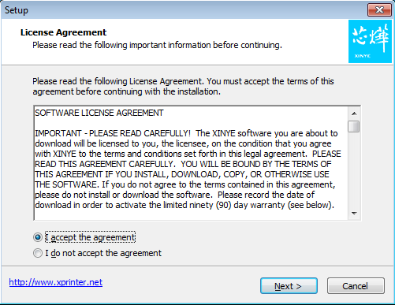

2.
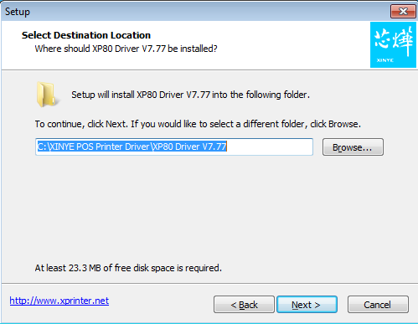

3.
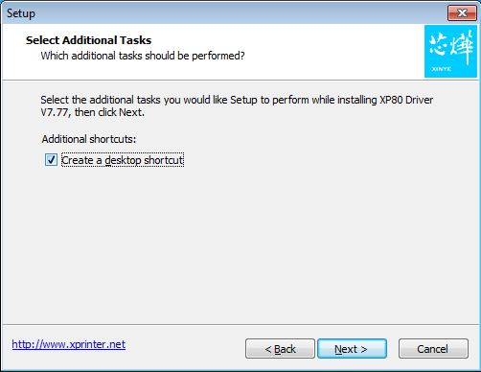

4.
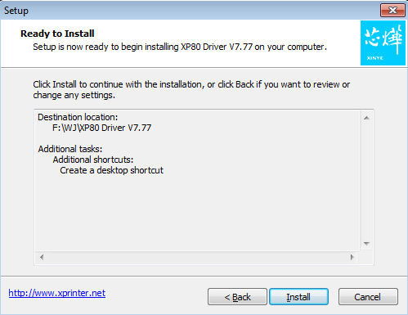

5.
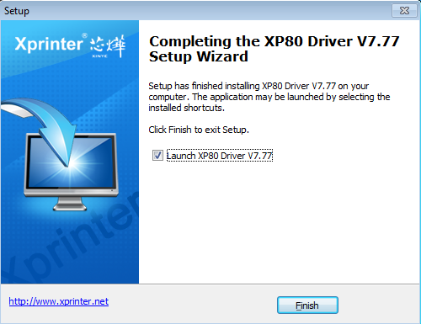

- If you want to use USB, so choose ‘USB’, If want Bluetooth, choose ‘Other’. Select Printer Series: XP-80C. Then click ‘Install Now’.
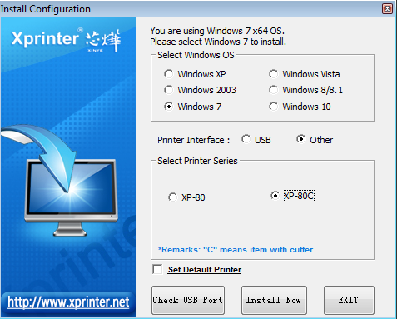

- Click ‘No’. This means you install successfully.
